Special Educational Needs:
Information Report
2023 - 2024

How we support children with Special Educational Needs or Disabilities

“By recognising Jesus Christ in ourselves and others, our school strives to be a living Christian Community which values and nurtures each individual through a sound education and encourages responsible attitudes towards our changing world.

___________________________________________________________________________

St. Louis Catholic Academy is a primary school and nursery. We admit children from the age of three years to eleven years. At the end of Year 6 our pupils go on to a range of secondary schools, including St. Benedict’s Catholic School in Bury St. Edmunds, Newmarket Academy, Bottisham Village College and Soham Village College.

CEO (Trust) Mr Flavio Vittese
Primary Improvement Lead Mrs Clare Clark
Head Teacher Mrs Sue Blakeley
SENCo Mrs Kerri Conway
Governor responsible for Safeguarding Mrs Karen Varma
Governor responsible for SEND Mrs Jenny Balmer

Welcome to our SEN Information Report which is part of St Louis Catholic Primary Academy’s contribution to the Suffolk Local Offer for learners with Special Educational Needs (SEN) and disabilities, which can be found here: https://infolink.suffolk.gov.uk/kb5/suffolk/infolink/localoffer.page
St Louis 2022 – 2023 SEN Report
Total Number of Pupils (Jan 2023) | 321
Pupils on SEN Record | 32 | 10%
Pupils with EHCP | 1 | 0.3%
Pupils with SEN Support | 31 | 9.7%

The majority of children’s primary SEN at St. Louis is Cognition and Learning at 54% with Communication and Interaction at 9%, Social, Emotional or Mental Health 25% and Sensory/Physical 12%. We do have children whose areas of need overlap and many children have more than one area of need – this pie-chart is simply a representation of each child’s primary area of need as identified by class teachers or other professionals. Therefore, it is important to note that although a child’s primary need may be Communication and Interaction or Cognition and Learning, they may still have support for Social, Emotional and Mental Health Needs. The high level of Cognition and Learning need is reflected in the provisions we offer within school, though we realise the value of all types of therapies and interventions and we adapt to the needs of the learners in our care.

Below are the four broad areas of SEN and how they may present.
We adapt our teaching and learning for children with SEN to offer personalised education. Every child at St Louis Catholic Primary Academy benefits from high quality teaching. Children on the SEN record may also access additional interventions or teaching and learning strategies to enable them to make the best possible progress.

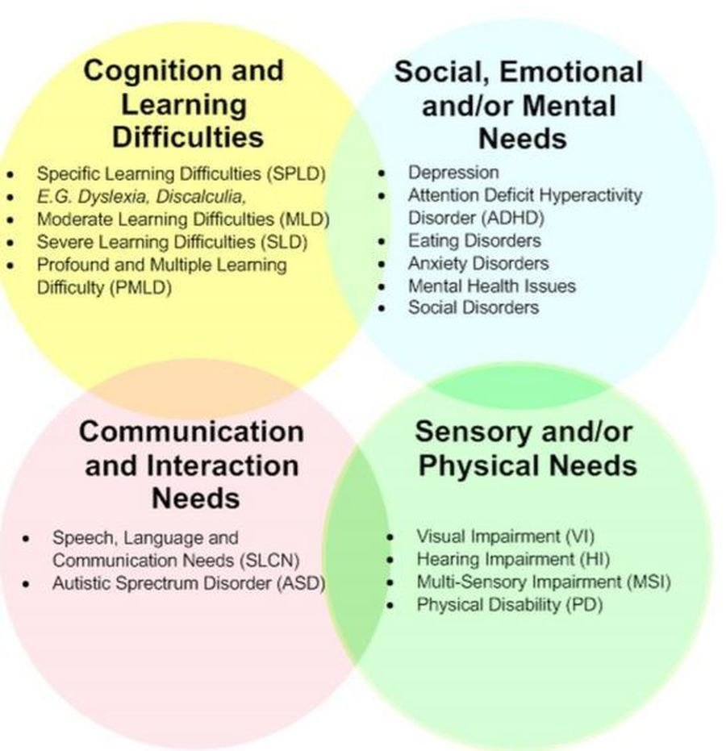

How we ensure that children who need extra support to ensure progress are identified early?
A child has a Special Educational Need if he or she has a learning difficulty or disability that means he or she has a significantly greater difficulty in learning than the majority of others of the same age, or has a disability which prevents or hinders him or her from making use of facilities of a kind generally provided for others of the same age in mainstream schools.

What is SEN Support?

SEN Support is the system we use in school to assess whether a child has special educational needs and then we can provide the right, targeted support.

Children are identified as having special educational needs in a variety of ways including the following:
- Child performing significantly below age expected levels (normally 18 months+)
- Concerns raised by parent
- Concerns raised by class teacher
- Consultations between class teachers and head teacher where progress data is discussed
- Liaison with external agencies e.g. Speech and Language Therapy Service
- Health diagnosis through a paediatrician
- Liaison with previous school or setting, if applicable

If a concern is raised regarding a child, a range of evidence will be collected through assessment and monitoring, including the following:
- Early Learning Goals – Early Years Foundation Stage
- Year 1 Phonics Screening test
- National Curriculum Tests - Year 2 and Year 6
- A range of standardised tests
- Classroom observation

What should a parent do if they think their child may have special educational needs?

Talk to us. In the first instance contact your child’s class teacher. The teacher may make the decision to involve the Special Educational Needs Co-ordinator (SENCO) for further advice or information or you may contact the SENCO directly yourself by making an appointment through the school Reception office or by email at senco@stlouisacademy.co.uk.

How do we support children who have special educational needs?

We value high quality teaching for all learners and actively monitor teaching and learning in the school. Our teachers deliver quality learning opportunities which are adapted to the needs of all children through careful planning and scaffolding. We aim to create a learning environment which is flexible enough to meet the needs of all members of our school community. Staff continually assess and monitor the progress of all of our pupils to enable us to identify any gaps in their learning and intervene early. The majority of our SEND support is carried out in the classroom to promote inclusion, ensure every learner has access to a broad and balanced curriculum as well as Quality First Teaching.

We believe that, where possible, Quality First Teaching should cater for all children’s needs. Reasonable adjustments should be made to ensure all pupils have access to learning and overcome any barriers to progress. Every teacher is required to adapt the curriculum to ensure access to learning for all children in their class. The teacher standards (2012) detail this expectation. Our teachers use various strategies to adapt access to the curriculum including visual timetables, concrete materials, coloured overlays, tablets, laptops, positive behaviour reward systems, writing frames and individual behaviour plans. We are also equipped with disabled toilets and a lift for children with physical difficulties or who have intimate care requirements.

The table below details the structured support we put in place and the order in which this will occur.

Universal offer- has an identified additional need but is making good progress | - Needs met through QFT  - Advice sought from SENCO where needed  - Progress monitored through termly Pupil Progress meetings  - Monitoring from SENCO through learning walks/book scrutinies/pupil voice  - Parents evenings  - Access to training as appropriate  - Whole school policies and procedures in place
Universal targeted – needs are not being met through QFT | - Teacher seeks advice from SENCO  - Child added to SEN Record and an individual learning plan is created between teachers and parents  - Appropriate interventions put in place using resources from within school.  - Progress of interventions monitored closely through provision map  - Use of additional assessments where needed
Targeted – child needs resources or support from one or more outside agencies | - SENCO seeks advice from external agencies  - Additional training may be needed to support the child in school  - SENCO may make referral to specialist education services  - Consider EHA assessment
Targeted Specialist – child needs a range of outside specialist support | - Child has multi agency involvement  - Child will be working towards, or will already have, an EHCP  - SENCO to seek advice where necessary from outside specialists  - Training for adults involved in the care of the child  - Specialist assessments are used to recognise steps in learning  - Monitoring of the support being provided  - Regular communication with parents

What is a Learning Plan?

Pupils with SEN at St Louis have a personalised Learning Plan which identifies their barriers to learning and how we intend to support them moving forward. This closely monitors progress and celebrates achievement. This support your child may receive is described on our provision map. The ‘Assess, Plan, Do, Review’ cycle is used at least termly in order to set appropriate targets for progress and put support in place. Whilst the majority of children’s needs are catered for within the classroom, we have a number of programmes to support pupils further if necessary.

These programmes include:
- Small group Maths or English based key skills lesson
- 1st Class @Number
- Additional Little Wandle Phonics
- Social, Emotional and Behavioural Skills group
- Literacy gold
- Dynamo Maths
- Speech and Language: NELI and Wellcomm

Other strategies we may use to support children in their learning include:
- Adult support where appropriate
- Flexible groupings
- Visual and multi-sensory resources
- Specialist equipment e.g. pencil grips, wobble cushions
- Individual timetables

Assess: Discussion with staff to build profile of need. Gather and analyse assessment information.
Review: Check the quality, effectiveness and impact of the provision, involving the child and their parents/carers.

Child

Do: Put in place the agreed adjustments, support and interventions.
Plan: Work together to create 7C’s Learning Journey, utilising whole school approaches, quality first teaching and adaptation strategies.

Who are the other people providing services to children with SEN?

St Louis Catholic Academy has close working relationships with a number of external agencies, whose specialist knowledge and advice enhance children’s learning and wellbeing. These agencies include:
- Community Consultant Paediatricians
- Speech and Language Therapy
- Occupational Therapy
- Physiotherapy
- Educational Psychology
- Specialist Education Service
- Advisory Teacher - Communication and Interaction
- Advisory Teacher – Cognition and Learning
- Advisory Teacher – Social, Emotional and Mental Health
- Advisory Teacher- Sensory and Physical Schools’ Nursing Service
- Family Support Practitioners

How are the school’s resources allocated and matched to children’s special educational needs?

We ensure that all children with special educational needs are provided for to the best of the school’s ability with the funds available. The budget is allocated on a needs basis to ensure that each child receives the support they require to enable them to make progress. The head teacher is responsible for allocating funding for supporting children and she consults with the business manager, SENCO and class teachers so that the best use possible is made of the funds available. The school is committed to offering appropriate support to all children and if a child needs additional support we strive to provide this. The school keeps a register of all children who require significant additional support. If a child makes good progress and meets the targets that have been set for them, they may be removed from the register. Monitoring of progress takes place for all children and this will still occur on an ongoing basis to ensure continued progress.

How do you measure my child’s progress?

As a school we measure children’s progress in learning against national age-related expectations (ARE). The class teacher continually assesses each child and notes areas where they are improving and where further support is needed. We track children’s progress from their admission through to Year 6, using the electronic systems, Evidence Me (EYFS), PiXL (Year 1 to 6) and Insight Tracker. When a child’s 7C’s Learning Portfolio is reviewed, comments are made against each target to show what progress has been made. If the child has not met the target, the reasons for this will be discussed, then the target may be adapted into smaller steps or a different approach may be tried to ensure the child does make progress.

How will my child be included in activities outside the classroom including day and residential trips?

We aim for all children to be included on school day trips and residential stays. We will provide the necessary adaptations, having consulted with parents, to ensure that this is successful. A risk assessment is carried out prior to any off-site activity to ensure everyone’s health and safety will not be compromised.

How will we support your child when they leave our school or move into another class?

Before your child moves between classes, their current class teacher will meet with their new class teacher to share information and records. This enables the new class teacher to be best prepared and aware of any adaptations necessary for your child to make transition as smooth as possible. A transition visit may be arranged at the end of the summer holiday when the child can see their new classroom and meet their teacher.
Prior to transition between our school and secondary schools, the secondary school SENCO will meet with our SENCO and class teachers to discuss your child’s needs and may offer your child a series of transition sessions at their new school.

How are school Governors involved and what are their responsibilities?

The SENCO reports to the Governors to inform them about the progress of children with special educational needs or disabilities; this report does not refer to individual children and confidentiality is maintained at all times.

One of the Governors is responsible for special educational needs and meets regularly with the SENCO. She shares the responsibility to ensure all governors are informed about SEND matters with the SENCO.

How is St. Louis Catholic Academy accessible to children with SEN?

The new building in our school is fully accessible for children with physical needs, as there are ramps throughout and a lift to the first floor for easy access as well as accessible toilets. The organisation of classes within the old building would be reviewed to facilitate access for children with physical needs, as necessary. Several adaptations have been added to the ground floor, including a disabled toilet, a ramp, Disability Discrimination Act (DDA) approved hand rails and disabled parking space to the front of the building. There is currently ramp access to the Nursery class. All staff have access to SMART Boards and visual timetables are available. In addition, specialist equipment or resources can be adapted or ordered for individual children as and when they are deemed necessary.

